**Department of _Computer Science and Engineering**

**MIT SCHOOL OF COMPUTING**

**MIT ADT University, Loni Kalbhor, Pune**

**Instructions for B.Tech. Project Report Writing**

* Project Report should include necessary certificates, acknowledgment, tables, list of diagrams, abstract, annexure (i.e., Paper), index.(pages from 60 to 90)
* If particular part is repeated, you can mention “Refer Page No. and point” or “Refer Annex
* Prepare at least **n + 2 Project Report** copies of your manuscripts for student, Guide, Department, University/Library. Submit soft copy in CD.
* Acknowledgment, List of Publications, List of Diagrams, List of Tables, Abstract should have page nos I, II, III, IV respectively.
* Always place the images/Diagrams/Table at the beginning or end of the page.
* The footer “**MITSOC, Department of Computer Engineering <year YYYY>**” should be included. (10, Times Roman, Center justified) from Introduction page
* Main part of manuscripts should be **Times Roman, 12 pts, justified** and **1.5 line spacing**(Should be Printed on both side of paper)
* Use paper size **8.5” x 11”** or **A4** (210 x 197 mm). Follow following margins.

|  |  |  |  |
| --- | --- | --- | --- |
| **Margin** | **Paper A4** | **Margin** | **Paper A4** |
| Top | 1” | Bottom | 1 |
| Left | 1.25 | Right | 1 “ |

All paragraphs will be single **line spaced** with a 1.5 line **space** between each paragraph. Each paragraph will begin with a **two-space indentation.**

* Chapter **titles** should be **bold** with **18 pt** typed in all **CAPITALS** letters and should be aligning at the **center** of the page.
* **Section heading** should be aligning at the **left** with **12 pt** and **bold** and **capitalized**.
* Section **subheading** should be aligning at the **left** with **title case.**
* Leave **one** spaces between section heading and **10 pt** space between two-section subheadings.
* References should be in IEEE format, in the order as they **appear in the dissertation**.
* Symbols and notations if any should be included in nomenclature section only.
* All chapters, section heading and sub headings should be numbered. For chapter use numbers 1,2,3 and for sub headings 1.1, 1.2, 1.3. And section subheadings 2.1.1, 2.1.2 etc.

The text should be typed on both side of the paper.

**A PROJECT REPORT ON**

**HOTEL BILL SYSTEM WITH SPLIT BILL FEATURE AND USER FRIENDLY UI**

SUBMITTED TO

MIT SCHOOL OF COMPUTING, LONI, PUNE IN PARTIAL FULFILLMENT OF THE REQUIREMENTS FOR THE AWARD OF THE DEGREE

**BACHELOR OF TECHNOLOGY**

**(Computer Science & Engineering)**

**BY**

Naman Babbar MITU22BTCS0467

Goutam Kumar MITU22BTCS0303

Khwaish Agarwal MITU22BTCS0390

Vasu Kamra MITU22BTCS0963

**Under the guidance of**

Prof/Dr/ Nilesh Kulal



**DEPARTMENT OF COMPUTER SCIENCE AND ENGINEERING**

**MIT School OF COMPUTING**

**MIT Art, Design and Technology University**

**Rajbaug Campus, Loni-Kalbhor, Pune 412201**

**2023-24**



**MIT SCHOOL OF COMPUTING**

**DEPARTMENT OF COMPUTER SCIENCE AND ENGINEERING**

MIT ART, DESIGN AND TECHNOLOGY UNIVERSITY,

RAJBAUG CAMPUS, LONI-KALBHOR, PUNE 412201

**CERTIFICATE**

**“Hotel Bill System With Split bill Feature and User Friendly UI”**

Submitted by

Naman Babbar MITU22BTCS0467

Goutam Kumar MITU22BTCS0303

Khwaish Agarwal MITU22BTCS0390

Vasu Kamra MITU22BTCS0963

is a bonafide work carried out by them under the supervision of Prof/Dr/ Nilesh Kulal and it is submitted towards the partial fulfillment of the requirement of MIT ADT university, Pune for the award of the degree of Bachelor of Technology (Computer Science and Engineering)

**Prof. PQR Dr.xyz**

Guide Head of Department

**Dr. ABC Dr. DEF**

Director Dean

Seal/Stamp of the College

Place: PUNE

Date:

**On Company Letter head/seal**

**CERTIFICATE**

This is to certify that the Project report entitled

**“Hotel Bill System With Split bill Feature and User Friendly UI”**

Submitted by

Naman Babbar MITU22BTCS0467

Goutam Kumar MITU22BTCS0303

Khwaish Agarwal MITU22BTCS0390

Vasu Kamra MITU22BTCS0963

is a bonafide work carried out by him/her (with the Sponsorship from ------------) under the supervision of Mr/Ms/Miss. ………………………….. and has been completed successfully.

(Mr. ……………… )

(Designation)

External Guide

(12, Sentence case) Seal/Stamp of the Company/College

Place :

Date :

**DECLARATION**

We, the team members

|  |  |
| --- | --- |
| Name | Enrollment No |
| Naman Babbar | (MITU22BTCS0467) |
| Vasu Kamra | (MITU22BTCS0963) |
| Khwaish Agarwal | (MITU22BTCS0390) |
| Goutam Kumar | (MITU22BTCS0303) |

Hereby declare that the project work incorporated in the present project entitled **“Hotel Bill System With Split bill Feature and User Friendly UI”** is original work. This work (in part or in full) has not been submitted to any University for the award or a Degree or a Diploma. We have properly acknowledged the material collected from secondary sources wherever required. We solely own the responsibility for the originality of the entire content.

Name & Signature of the Team Members

Member 1: Naman Babbar

Member 2: Vasu Kamra

Member 3: Khwaish Agarwal

Member 4: Goutam Kumar

**Name and Signature of Guide**

Seal/Stamp of the College

Place: Pune



DEPARTMENT OF COMPUTER SCIENCE & ENGINEERING

MIT SCHOOL OF COMPUTING,

RAJBAUG, LONI KALBHOR,

PUNE – 412201

**EXAMINER’S APPROVAL CERTIFICATE**

The project report entitled “Hotel Bill System With Split bill Feature and User Friendly UI” submitted by Naman Babbar (MITU22BTCS0467), Vasu Kamra (MITU22BTCS0963), Khwaish Agarwal (MITU22BTCS0390), Goutam Kumar (MITU22BTCS0303) in partial fulfillment for the award of the degree of Bachelor of Technology (Computer Science & Engineering) during the academic year 2022-23, of MIT-ADT University, MIT School OF COMPUTING, Pune, is hereby approved.

**Examiners:**

**1.**

**2.**

**ACKNOWLEDGEMENT**

**Name, Enrollment No.**

**ABSTRACT**

*The rapid and intricate process of information diffusion, particularly within the context of online social networks, is a topic of growing interest. This report delves into the dynamics of information diffusion, exploring the mechanisms and patterns of how information spreads through various channels. We examine the role of community detection and influential nodes in shaping the path of information within online social networks, shedding light on the dynamics that underlie this process. Additionally, the report discusses the application of topic modeling and trend detection in understanding the content and evolution of information. Real-world examples and case studies illustrate the practical implications of information diffusion in fields such as marketing, public policy, and crisis management. Amidst the opportunities, we also address the challenges related to misinformation and emphasize the ethical considerations associated with the flow of information. Ultimately, this report highlights the importance of comprehending information diffusion in our information-rich society and the potential for harnessing it effectively.*

**CONTENTS**

|  |  |
| --- | --- |
| Certificate ………………....………………………….…………. | i |
| Certificate (From Company If Any) …………………...………. | ii |
| Declaration ……………….…………….………………....………. | iii |
| Examiner’s Approval Certificate …………………………………. | iv |
| Acknowledgement ……………….…………………..……………. | v |
| Abstract …………………………………………..…...……………. | vi |
| List of Figures ………………………..………….…………………. | viii |
| List of Tables ……………………….…………….…………………. | ix |

Chapter 1 INTRODUCTION 1

1. Introduction 1

1.1 Digitalization in Labor Market: 2

2. Existing Work 3

3. Motivation 3

4. Objectives 4

5. Scope 4

Chapter 2 CONCEPTS AND METHODS 5

2.1 definitions 5

Chapter 3 LITERATURE SURVEY 7

Chapter 4 PROJECT PLAN 10

Chapter 5 SOFTWARE REQUIREMENT SPECIFICATION 11

5.1 Project scope 11

5.2 User Classes & Characteristics Coder 11

Chapter 6 RESULTS 12

Chapter 7 SOFTWARE TESTING 13

Chapter 8 CONCLUSION AND FUTURE WORK 14

BIBLIOGRAPHY 15

ANNEXURE A: List of Publications and Research Paper (In its Original formats) 16

ANNEXURE B: Plagiarism Report 17

ANNEXURE C: Empathy Chart and Solution Document

Annexure D: Project Tracker

**LIST OF FIGURES**

|  |
| --- |
| Figure Number: Figure of the table Page Number |

Figure 2.1: python logo 14

Figure 2.2: Tkinter Logo 14

FIGURE4.1:SOFTWARE MODELING 17

**LIST OF TABLES**

|  |
| --- |
| Table Number: Title of the table Page Number |

Table 2:1:Existing Work 12

Table 3:1: Literature Survey 15

TABLE 3.2: RESEARCH SURVEY 16

# INTRODUCTION

## Introduction

In the dynamic environment of today's hotel industry, the hotel's payment system is an important junction where guests can meet business efficiency. Changes are being made to redefine these fundamental concepts to meet the evolving preferences and expectations of today's travelers. At the forefront of this evolution is the integration of common functionality, complemented by a user-friendly interface (UI).

This report provides a comprehensive study of the changing trends in hotel pricing. We explored the great potential of a carefully designed, user-friendly user interface and distributed billing to ensure communication and customer satisfaction. The once complex and time-consuming process has been redesigned to make guests' stay easy, straightforward and enjoyable.

Our research is not only theoretical but also practical. We aim to provide a better understanding of how these resources work in different situations by examining real-world models and industry best practices.

The impact of this change goes beyond simplicity. These factors affect guest satisfaction, employee performance and the hotel's overall brand perception. In a rapidly evolving business, this report highlights the important role that user-friendly user interface and distributed billing functions play in maintaining competitive advantage and keeping guests happy.

We will explore how a user-friendly user interface and shared payment sources can improve the payment process, increase guest satisfaction, and meet the changing needs of travelers in hopes of digital advancement and customer centricity.

By conducting in-depth research on this innovation, we aim to provide hotels, industry professionals and stakeholders with insight into the impact of these changes on the payment of fees in their hotels. Make it difficult for the problem to be adopted into the system. The future of premium hotel billing is here and this report will introduce you to its uses and benefits.

## Existing Work

There are a few existing systems related to our project field. After some research and analysis, we came across the methodology of the system and a few of its drawbacks. The below table gives us the gist about these existing systems:-

|  |  |  |
| --- | --- | --- |
| **SYSTEM** | **DESCRIPTION** | **LIMITATION** |
| SPLITWISE | While not specific to hotels, Splitwise is a popular app for splitting bills among friends or groups, which can be handy when sharing expenses at a hotel or restaurant. | Splitwise relies on an internet connection to sync data and make updates. This can be inconvenient if you're in an area with poor connectivity or traveling abroad without a data plan**.** |
| Tab | Tab is designed for splitting restaurant bills, making it easy to share expenses with your dining companions**.** | The effectiveness of bill-splitting apps like Tab depends on users accurately inputting expenses and payments. |
| Splitter | A "Splitter App" is a mobile application designed to simplify the process of dividing expenses and bills among friends, family, or groups. | The app's success depends on the willingness of all participants to actively use it and regularly update their shared expenses. |
| Splid | Splid is a mobile app designed for hassle-free bill splitting and expense sharing among friends, family, or groups**.** | As with any app that involves sharing financial data, users should be cautious about privacy and security. Always ensure that the app you use has strong security measures in place. |

**Table 2.1 Existing Work**

## Motivation

Transforming hotel invoices by integrating customer experience into the user interface and distributing invoices is more than just a technology upgrade. A major change in the hotel industry that is redefining the guest experience of knowledge. This change is not only a response to changing expectations, but also an important step to raise awareness and satisfaction in travelers.In addition to increasing guest satisfaction, this change also increases efficiency. By simplifying billing for groups, meetings and events, hoteliers can reduce administrative responsibilities and increase employee productivity.

In our research, we will not only introduce theoretical knowledge, but also offer practical advice from real-world models and business best practices.

However, as we enter this path, we must be aware of the problems and ethical rules that come with change. Data security and fair use of these features are important. Therefore, it is important that hotel staff follow the rules and follow clear instructions.

In conclusion, what motivated us to embark on this journey is the huge impact that a user-friendly user interface and distributed payment system will have on the future of the hotel. Hospitality industry. As we explore this shift, we will find the ability to increase guest satisfaction, simplify operations, and provide a competitive advantage in a fast pace of business. Our goal is to provide you with the knowledge and understanding you need to benefit from these innovations and provide your guests with an experience that exceeds their expectations.

## Objectives

* Give your audience a better understanding by providing a comprehensive overview of the challenges and changes in hospitality practicing.
* Processes in increasing customer satisfaction and trust in the hospitality industry, welcoming guests.
* Highlighting the critical role of billing
* Demonstrate the benefits of integrating Split Billing functionality into your hotel billing by focusing on simplicity and fairness.
* Explain the concept of pricing and demonstrate its importance in meeting the needs of today's customers today.

## Scope

* Creating an intuitive, responsive, and visually appealing interface for the hotel billing system.
* Developing a user-friendly feature for splitting bills among multiple guests.
* Seamlessly integrating the new GUI and bill splitting feature with the existing billing system.
* Enhancing user experience through real-time feedback and error handling..

# CONCEPTS AND METHODS

## 2.1 definitions

**Python:** Python is an interpreted, object-oriented, high-level programming language with dynamic semantics. Its high-level built in data structures, combined with dynamic typing and dynamic binding, make it very attractive for Rapid Application Development, as well as for use as a scripting or glue language to connect existing components together. Python's simple, easy to learn syntax emphasizes readability and therefore reduces the cost of program maintenance. Python supports modules and packages, which encourages program modularity and code reuse. The Python interpreter and the extensive standard library are available in source or binary form without charge for all major platforms, and can be freely distributed.

**Figure 2.1: Python Logo**



**Figure STYLEREF 1 \s 2. SEQ Figure \* ARABIC \s 1 1: This is my First Figure**

**Tkinter:** Tkinter is an open source, portable graphical user interface (GUI) library designed for use in Python scripts.Tkinter relies on the Tk library, the GUI library used by Tcl/Tk and Perl, which is in turn implemented in C. Therefore, Tkinter can be said to be implemented using multiple layers.Several competing GUI toolkits are available to use with the Python language.

**Figure 2.2: Tkinter Logo**



# LITERATURE SURVEY

**Table 3:1: Literature Survey**

|  |  |
| --- | --- |
| **Current Billing Systems** | We looked at how hotels currently handle their billing processes. This included examining the methods they use for splitting bills among guests and the technology they employ |
| **Customer Feedback** | We studied feedback and reviews from hotel guests to understand their experiences with billing systems. This feedback helped us identify common pain points and areas for improvement. |
| **Industry Best Practices** | We explored what other successful hotels are doing in terms of billing and user interface design. This involved analysing case studies and examples of hotels that have excelled in these areas. |
| **Technology Trends** | We examined emerging technologies and trends in the hospitality industry related to billing and user interfaces. This included looking at how hotels are incorporating digital solutions to enhance the guest experience. |
| **Customer Expectations** | We considered what guests expect from a hotel billing system. This included understanding the preferences and demands of modern travellers when it comes to ease of use and clarity in hotel billing. |

|  |  |
| --- | --- |
| **Efficiency Studies** | We reviewed studies that have investigated the efficiency gains that hotels can achieve by improving their billing processes. This included looking at how streamlined billing systems can save time and resources for both guests and hotel staff. |
| **Guest Satisfaction Impact** | We examined research on the link between efficient billing and guest satisfaction. Understanding how improvements in billing can lead to happier guests was a key focus. |

**Table 3.2: Research Papers**

|  |  |  |  |  |
| --- | --- | --- | --- | --- |
| **Name** | **Author** | **Year** | **Advantage** | **Disadvantages** |
| Splitting Bills: All You Need to Know as Diners Go The Dutch Way | Prachi Ahuja | 2016 | Improved customer satisfaction as the split bill feature accommodates diverse guest needs, especially in group travel scenarios. | Billing complexity can lead to disputes and discomfort, highlighting the necessity for a split bill feature in the hotel billing system to streamline and simplify the process. |
| Bill Splitting And Expense Managing Assistant | Rishabh Agarwal | 2019 | The addition of a split bill feature simplifies expense management for hotel guests, reducing manual processes and enhancing their experience by minimizing billing disputes. | Privacy and data collection concerns may arise as guest financial information is collected and analyzed, necessitating potential privacy issues. |

# PROJECT PLAN

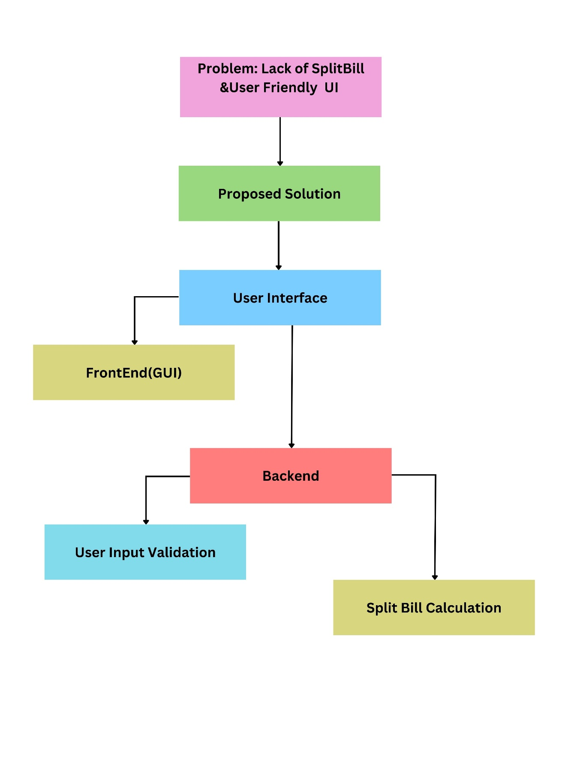**Figure 4.1: Software modeling**

# 

# SOFTWARE REQUIREMENT SPECIFICATION

## 5.1 Project scope

## Design and develop a hotel billing system that streamlines the check-out process and provides a user-friendly interface for both hotel staff and guests.

## Implement a bill-splitting feature that allows guests to split their bills easily among multiple guests or roommates.

## Enhance the overall guest experience by providing a seamless and efficient billing process.

## 5.2 User Classes & Characteristics Coder

* Backend development for bill calculations, payment processing, and bill splitting logic.
* User-friendly and intuitive front-end UI for both hotel staff and guests.
* User’s authentication and access controls for hotel staff.
* Integration with payment gateways for secure transactions.
* Testing, quality assurance, and user acceptance testing
* . Documentation, including user manuals and training materials.
* Deployment of the system to selected hotel locations.
* Post-implementation support, maintenance, and regular updates based on user feedback.

# RESULTS

The integration of a hotel bill system with user-friendly UI and split bill features in a hotel project yields several key results.

**First**, it significantly enhances guest satisfaction by providing a streamlined, transparent, and customized billing process. Guests enjoy empowerment and personalization options, leading to fewer billing-related disputes and increased trust in the hotel's services.

**Second,** this innovation improves operational efficiency. Administrative burdens associated with billing, particularly in group settings, are reduced. Staff efficiency is enhanced as the process becomes more automated and less error-prone. This results in streamlined back-end operations and cost and time savings.

**Third,** it offers a competitive advantage. The hotel gains an edge by providing a guest-centric and technologically advanced experience, leading to positive brand perception and the attraction of tech-savvy travelers.

**Fourth**, there's potential for further customization and development of mobile apps and web interfaces, adding more user-friendly interactions.

Overall, this project results in a positive impact on guest satisfaction, operational efficiency, and the hotel's competitive position in the market. It fosters a transparent and ethical billing process that garners positive guest feedback and trust.The benefits extend to group bookings, making it more attractive to event planners and group travelers**.**

# SOFTWARE TESTING

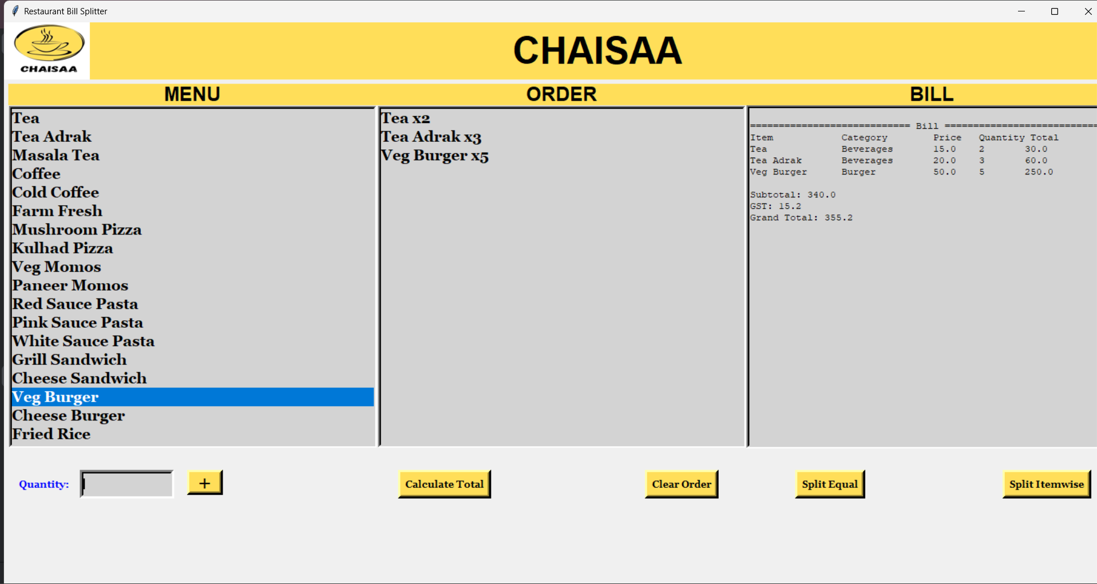

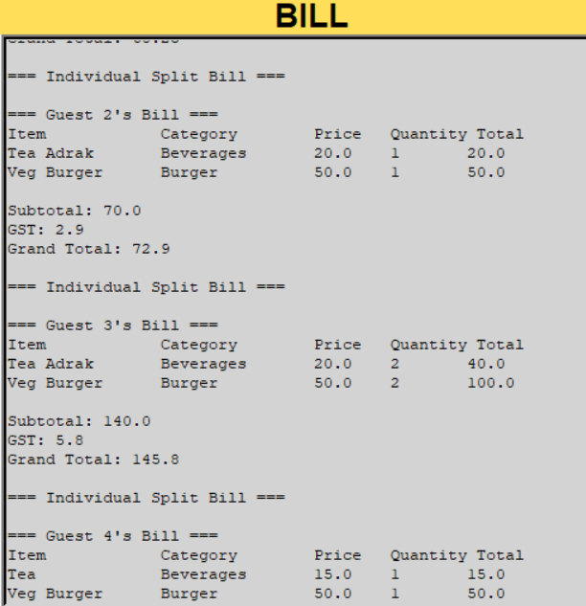

# CONCLUSION AND FUTURE WORK

The development of a Hotel Bill System with a Split Bill Feature and a User-Friendly UI is a significant undertaking with the potential to greatly improve the guest experience in the hospitality industry. The project's scope includes designing and implementing a system that streamlines the billing process, enhances the user interface, and allows for the convenient splitting of bills among guests. While the system's successful deployment brings numerous benefits, it also presents challenges and opportunities for future work.

The project, when successfully executed, offers the following advantages:

1**. Enhanced Guest Experience:** A user-friendly interface and a seamless billing process contribute to an improved guest experience, leading to higher guest satisfaction and potential repeat business.

2. **Efficiency and Accuracy:** The system's ability to accurately calculate bills and split them among guests reduces errors and simplifies accounting for both hotel staff and guests.

**Future Work:**

As technology and customer expectations continue to evolve, there are several opportunities for future work and enhancements in this domain:

1. **Mobile App Integration:** Consider developing a companion mobile app that allows guests to review and split bills from their smartphones, offering more convenience and flexibility.

2. **Integration with IoT Devices:** Explore the integration of Internet of Things (IoT) devices in hotel rooms to automate billing for in-room services, such as minibar usage or room service.

# BIBLIOGRAPHY

* [**https://www.posist.com/restaurant-times/features/splitting-bills-going-the-dutch-way.html**](https://www.posist.com/restaurant-times/features/splitting-bills-going-the-dutch-way.html)
* [**https://rady.ucsd.edu/_files/faculty-research/uri-gneezy/splitting-bill.pdf**](https://rady.ucsd.edu/_files/faculty-research/uri-gneezy/splitting-bill.pdf)
* [**http://troindia.in/journal/ijcesr/vol6iss10/16-20.pdf**](http://troindia.in/journal/ijcesr/vol6iss10/16-20.pdf)
* [**https://studyfinds.org/sharing-food-splitting-dinner-bill/**](https://studyfinds.org/sharing-food-splitting-dinner-bill/)

# ANNEXURE A: List of Publications and Research Paper (In its Original formats)

* POSIST PUBLICATIONS
* TROI INDIA
* STUDYFINDS.ORG

# ANNEXURE B: Plagiarism Report